COMP Cams® Adds Umbrella To Merchandise Offerings

Memphis, TN – A new golf-style umbrella from COMP Cams® is a must have for both rainy and sunny days at the track or car show.

The 48" diameter umbrella features the COMP Cams® logo and a carbon fiber-look shaft with a soft rubber handle grip for easy carrying. When you're ready to brave the elements, it easily folds down with a wraparound Velcro strap to keep it shut.

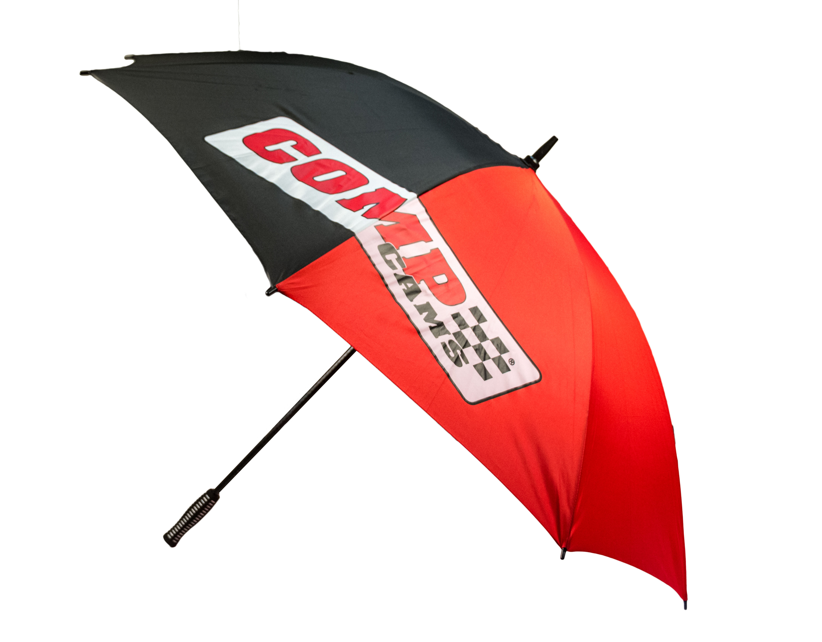
Quick Facts

Product: COMP Cams® Umbrella
Part Number: #C1042
Street Price: $20

Social Media Pitch: A 48” umbrella from COMP Cams® keeps you dry and stylish at the track or car show.

Features & Benefits:
Red and black, 48" diameter canopy, golf-style umbrella featuring the COMP Cams® logo
Carbon fiber look shaft with soft rubber handle grip for easy carrying
Folds shut with a Velcro strap

About COMP Cams®

Founded in 1976 and based in Memphis, TN, COMP Cams® has become the automotive performance aftermarket’s “Absolute Leader in Valve Train Technology.” Our mission is to produce the highest-performing products possible, provide superior customer service and lead the industry in technological development. Additional information about COMP Cams® and its products can be found at www.compcams.com or by calling 1.800.999.0853. You can also visit us on Facebook (facebook.com/COMPWins), Twitter (twitter.com/COMPCams), Instagram (instagram.com/compcamsofficial) and YouTube (CPGNationTV.com).

Media Contact: Cindy Bullion, cbullion@compcams.com, 901.795.2400 ext. 1643.

